Multi-Tiered Systems of Support (MTSS)-Fairfield Elementary School
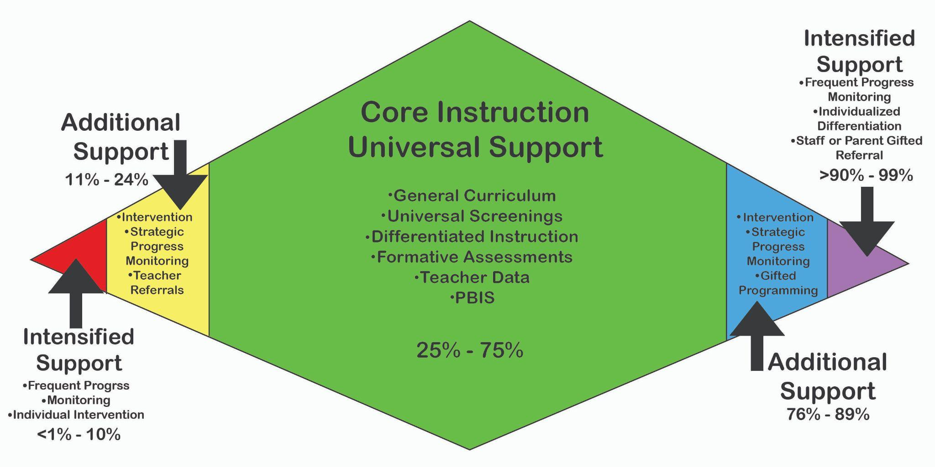

Tier Definitions:

Tier 1: UNIVERSAL, high-quality, differentiated research-based instructional and behavioral supports for all students to reach proficiency in general education
Roughly 80% of students (during a typical school year)
Tier 2: TARGETED, needs-based remediation intervention and support (in addition to Tier 1) for students whose academic performance or behavior lag behind the norm for proficiency in their grade and educational setting
Roughly 15% of students (during a typical school year)
Tier 3: INTENSIVE, customized interventions and support (in addition to Tier 1 and 2) for students who have not adequately responded to evidence-based interventions in the first two tiers. A psychoeducational evaluation may be recommended by the MTSS team if Tier 3 interventions are unsuccessful in meeting the student’s educational needs. Roughly 5% of students (during a typical school year)

MTSS Process at Fairfield Area Elementary School:

- All students are administered benchmark assessments (i.e., Acadience and Spring Math) three times per year.
- The MTSS Team/Interventionists meet to review the benchmark data and make Tier level recommendations to teachers. (Using Acadience data.)
- Teachers provide feedback/recommendations electronically (on the Google Doc) in the space provided. The MTSS Team/Interventionists can adjusts the Tier level groups based on teacher recommendations.
- The MTSS Team meets monthly, and more frequently as necessary, to analyze the progress monitoring data and classroom teacher updates.

Intervention Placement at Fairfield Area Elementary School:

- A student qualifies for tier 2 support (Targeted Support) if they score in the 11th%-24th% on Acadience Reading composite national percentile.
- A student qualifies for tier 3 support (Intensified Support) if they score <1st%-10th% on Acadience Reading composite national percentile. These students qualify for Title 1 services.
- We will add “support” groups in certain grade levels if we see a need for intervention in a skill area and have space available.

